Is this the end of an era?
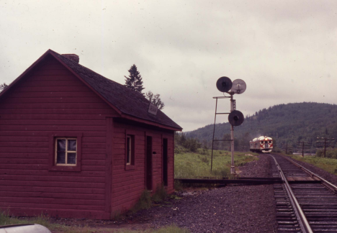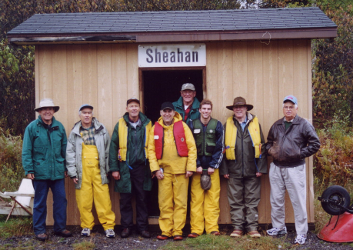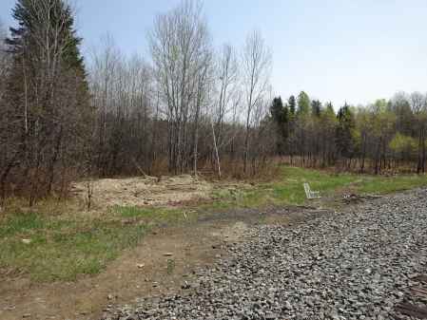

The photo of the smashed up and buried station cannot eradicate the memories I have of our former stations, as there two. Both buildings provided a meeting place to wait for the train and, most importantly a shelter from the bugs, rain, winds and snow storms.
stationmasters and section crews

When the CPR build the transcontinental in the early 1880's they chose stops at 6 to ten miles apart. Here they constructed stations for the stationmasters, who manned the telegraph, as it was the main means of communication, and section crews who maintained the roadbed. 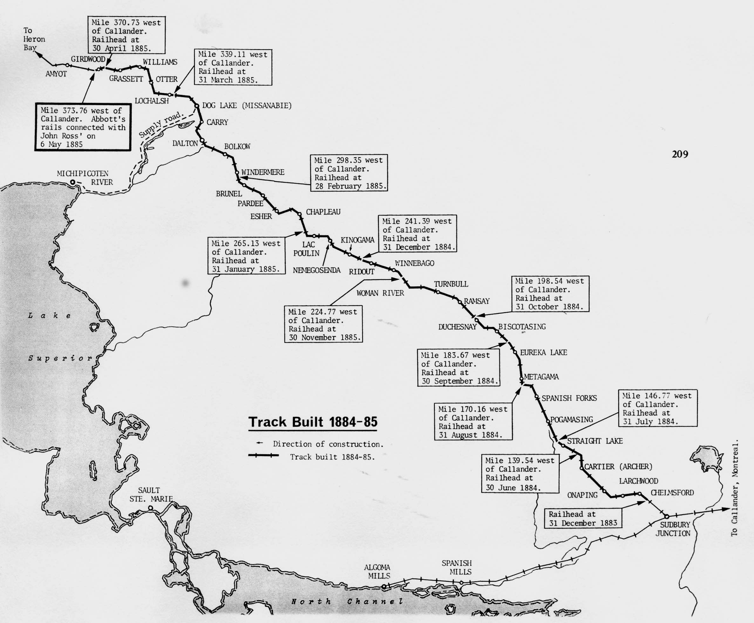

Our stop at Sheahan was not created until the lumber companies needed a place to bring supplies for their logging camps. Thus, the first stop was named "Munroe's Siding" after one of the first lumber men to establish a logging operation. By 1917 the name of the stop changed to Wye as the railway needed a way to turn the steam engine around and send it back to Cartier so it could help pull the heavy loads up the Stralak hill.

There were only a fw people living near the station prior to 1929 as most f the men were in the bush in the logging camps. There were warehouses, barns and a few houses for the few who worked there.

After W. B. Plaunt purchased the rights to the Pog Limit from his friend ...(and that's another story), he planned to build a sawmill to mill the jack, white and red pine he planned to float down the east branch of the Spanish River.

